Dear Environmental Activists,

Built on earlier conservation efforts that run through the core of American political life, environmentalism secured protections for air, water, land, and public health that made modern prosperity possible. Clean water and breathable air are not luxuries; they are baseline conditions of a properly functioning society. These achievements matter, and they endure.

Climate activism has not translated those successes into emissions reductions. Even as climate science moved from “inconvenient truth” to indisputable fact, global and U.S. emissions have continued to rise. What persists instead are false illusions: that better messaging will fix the problem; that incremental policy wins will compound into transformation; that disclosure and targets can substitute for confrontation with power. The reason for this lack of material progress is no longer ambiguous, and avoiding it is no longer practical. Meaningful climate action cannot occur while both major political parties remain aligned on fossil-fuel dependence and military interventionism.

Institutional access within a system structurally opposed to change yields only delay and false progress. By contrast, advocacy and protest can expose injustice, shift narratives, and force issues into view, but protest politics alone cannot plan energy infrastructure, coordinate land use, or steward society through systemic disruption. The Green Party clearly illustrates this distinction between moral clarity and institutional capacity. This observation is not a rejection of activism; it is an argument for political completion. The work now is to build new political forms capable of realizing democratic agency under climate collapse. That is the work the Mighty Oak Party exists to take on.

That work requires recognizing that climate collapse is not an issue to be managed alongside others, but a planetary emergency that challenges democratic governance itself. Climate activism can no longer remain embedded within environmental advocacy, issue coalitions, or lifestyle politics designed for a stable world. We therefore reject the fragmentation of climate into niche identities or secondary environmental concerns. Climate collapse is a universal, material threat that demands a majoritarian political project, one capable of occupying the political center without inheriting the compromises, dependencies, or corruption of a two-party system that has reached its terminal limits.

Those who understand that climate change is accelerating can no longer afford denial or comfort. America2050 is not a campaign slogan; it is the future we will be forced to govern. That future will produce new power centers shaped by habitability, water access, food security, and accelerating climate stress, whether existing parties prepare for them or not. The central obligation of the next phase is stewardship: of democracy, of social cohesion, and of collective survival in a century defined by planetary breakdown.
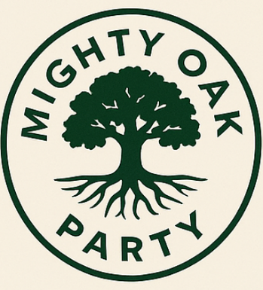
The Climate Century will not be navigated by pressure alone.
It will be governed—or it will not.

Respectfully,
The Mighty Oak Party
Rooted in the People

