Dear Assemblymember,
California has entered the climate century—a period defined not only by rising temperatures, but by sustained pressure on infrastructure, institutions, and public trust.
The state has taken meaningful steps toward decarbonization. California’s commitment to invest in offshore wind infrastructure, including the Humboldt Bay heavy-lift terminal, represents real progress and deserves recognition. These actions demonstrate that California can still act at scale when political will aligns with physical reality.
At the same time, the climate century demands more than individual projects or long-term targets. It requires governance systems capable of managing continuous transformation under conditions of ecological stress, historic population shifts, and political volatility produced by their convergence.
Several structural gaps remain difficult to ignore.
First, grid capacity, transmission, and interconnection continue to lag behind generation goals. Renewable deployment cannot deliver resilience if permitting, regional coordination, and infrastructure investment remain constrained by institutional inertia rather than material necessity. Targets alone do not substitute for physical readiness.
Second, California’s climate planning has not yet fully accounted for AI-driven load growth. Data centers, automation, and compute-intensive infrastructure are expanding rapidly, often with public support, yet their energy and water demands remain under-modeled in decarbonization scenarios. This creates a planning paradox: demand is treated as stable while policy incentives actively accelerate it. We are concerned that grid-expansion funding may be deployed reactively, prioritizing short-term load accommodation over long-term decarbonization, while exposing ratepayers to rising costs in the process.
Third, climate policy has become politically fragile. Even lawfully authorized programs have proven vulnerable to delay, litigation, and political interference. This volatility undermines long-term planning and erodes public confidence, regardless of stated ambition.
These realities point to a conclusion that must be stated plainly.
The Mighty Oak Party’s position is that California’s existing political and policy framework is not capable of delivering the scale, speed, or continuity of transformation the climate century requires. This is not a rejection of California’s climate institutions, nor an accusation of bad faith. It is a recognition that the political process is structurally mismatched to catastrophic risks unfolding over timelines longer than one or more election cycles.
For this reason, we hold that representative government must be strengthened from the outside, not merely relied upon.
The Mighty Oak Party is therefore working to form the Bay Area’s first Local Assembly: a nonpartisan, community-based forum for sustained public deliberation on climate risk, infrastructure priorities, and democratic continuity. As outlined in our America 2050 framework, the decades ahead are more likely to be characterized by fragmentation and improvisation than by sudden collapse. Infrastructure replacement will lag behind disaster frequency. Federal programs will strain unevenly. States will expand emergency powers asymmetrically. Under such conditions, long-term stability depends increasingly on local civic capacity.
This letter is intended to clarify how we understand the present moment and the course of action we are pursuing in response. We offer it as a statement of position, grounded in long-horizon risk and institutional capacity, and as part of a broader public record—reflecting the conclusion reached by informed citizens that existing political alignments are not capable of preventing escalating human suffering at the scale the climate century will produce.
We welcome your continued efforts to advance climate resilience and clean-energy deployment, and we invite you to engage with emerging civic models designed to meet the scale of the challenge ahead.
The climate century will not be navigated by targets alone.
It will be shaped by institutions willing to speak plainly about reality—and communities empowered to deliberate about their future.
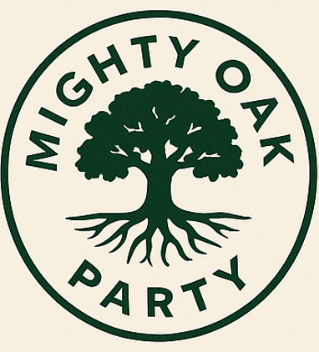
Respectfully,
The Mighty Oak Party
Rooted in the People

